**CHATBOT**

Using Google Dialogflow

“There are many ways to upgrade communication between your company and its customers. One effective method (both in terms of cost and results) for any business to improve their customer service game is by using ***chatbots***. Recently, chatbots have been applied in many different aspects of business and have had many proven records of success.”

Generally speaking, a **bot** is a piece of software designed to perform an **automated task**. And a chatbot is supposed to conduct a conversation with a human using textual or auditory methods. Chatbots simulate how a human would behave as a conversational partner and thus can answer questions and carry the conversation.

There are two important reasons to make a chatbot an effective customer service agent for your business, one is Customers Prefer Texting and, another one is Chatbot is Instant & 24/7.

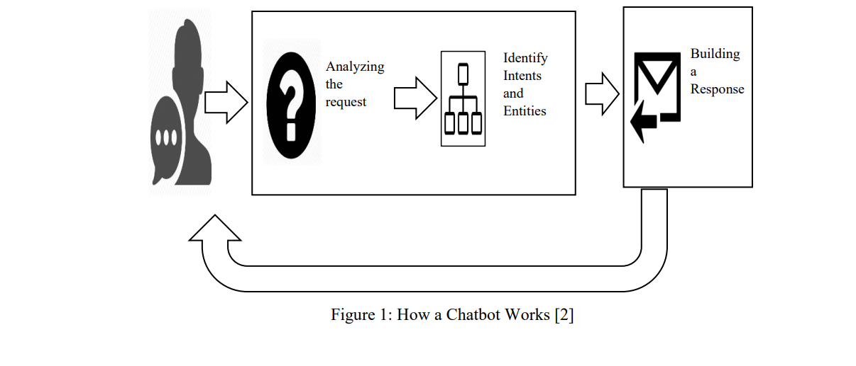

There are two primary kinds of chatbots a business can use:

1. Transactional Chatbot
2. Conversational Chatbot

Now let us look at Chatbot Use Cases in Customer Service:

1. Chatbots answer questions and inquiries.
2. Book tickets to events/shows with chatbots.
3. Use chatbots to find products, check inventory and recommend items.
4. Chatbots to build remarkable customer experience.
5. Chatbots can process return and exchange requests.
6. Chatbots can confirm orders and track shipping.
7. Chatbots help you collect customer feedback efficiently.
8. Chatbots assign customer requests to support teams.
9. Chatbots generate leads with sales approach.
10. Chatbots promote products with fun conversations.

And of course, the above list of use-cases is not exhaustive. Chatbots can certainly do much more. Every single year, the interaction between customers and chatbots keeps increasing. For example, it is predicted that chatbots will handle up to 85% of all customer interaction requests by 2020, which would significantly cut costs and free up employees' time for more demanding tasks.

Plus, let’s not forget that chatbots give companies the ability to provide 24/7 instant services to customers in a human-like manner. Such a fast and smooth customer service help companies build brand loyalty and bring new clients to the business with lower advertising costs. Just take a look at this or this case study on how chatbots help companies increase customer satisfaction score and provide a superior service.

I want to create a chatbot for my restaurant to manage orders, increase sales, answer frequently asked questions, and much more. Now let us build a chatbot for a restaurant named “MyFood Restaurant”. This chatbot of restaurant is a conversational software to answer frequently asked questions, take orders, ask for feedback, and show the delivery status of the client’s order.

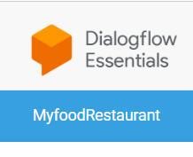MYFOOD RESTAURANT

Chatbot

A chatbot for restaurants looks something like this:

*What can a chatbot be used for in a restaurant?*

1. Suggesting menu items
2. Making reservations
3. Collecting feedback
4. Simplifying the order process
5. Providing customer service

How I built the chatbot for this restaurant?

Step 1: **Creating an agent**

I have created an agent called Myfood_Restaurant, which is used to handle conversation with your end-users.

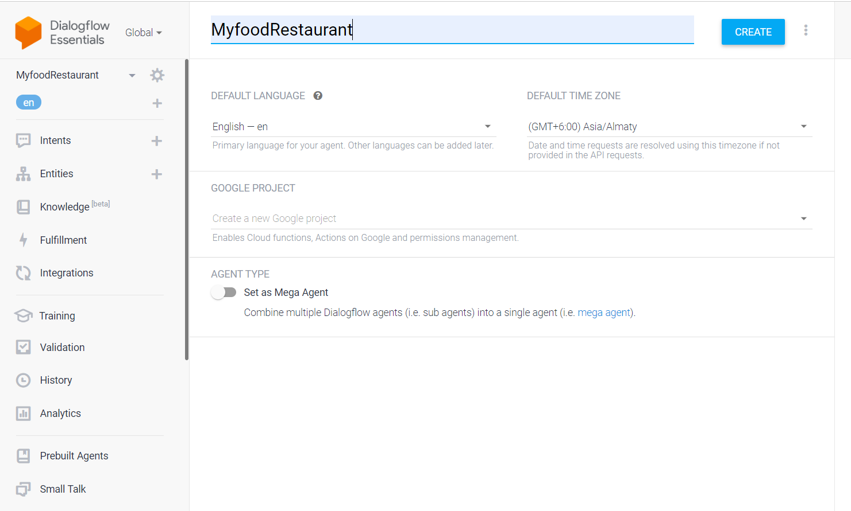

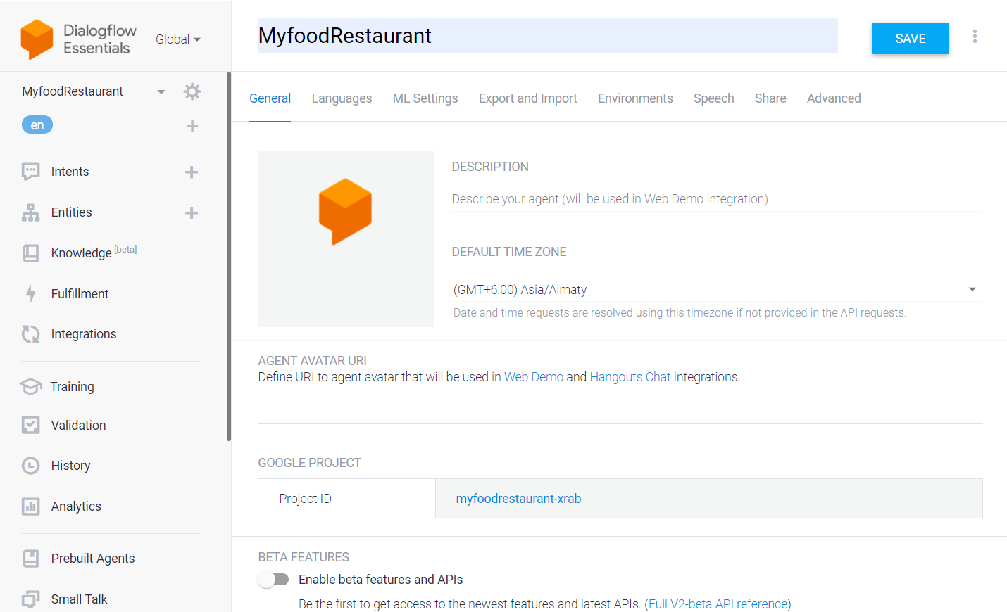

Step 2: **Enable a small talk**

I have enabled small talk, so that my agent can learn how to support small talk without any extra development. By default, it will respond with predefined phrases. Below are customize responses to the most popular requests.

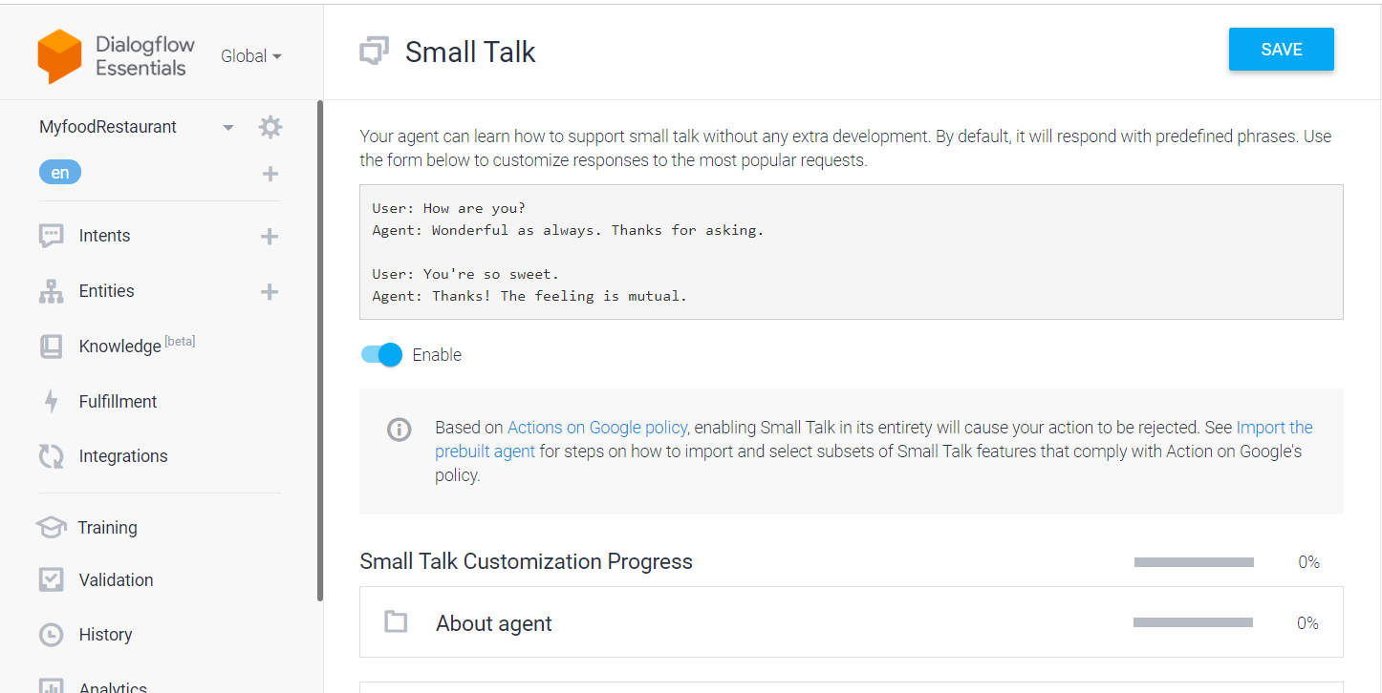

Step 3: **Defining Entities**

Entities can be fields, data, or text describing just about anything — a time, place, person, item, number, etc. Using natural language processing (NLP), chatbots can extract entities from entries that users type in in order to turn around accurate recommendations and answers.

In this chatbot I have created entities as type of items, menu and quantity, etc.,

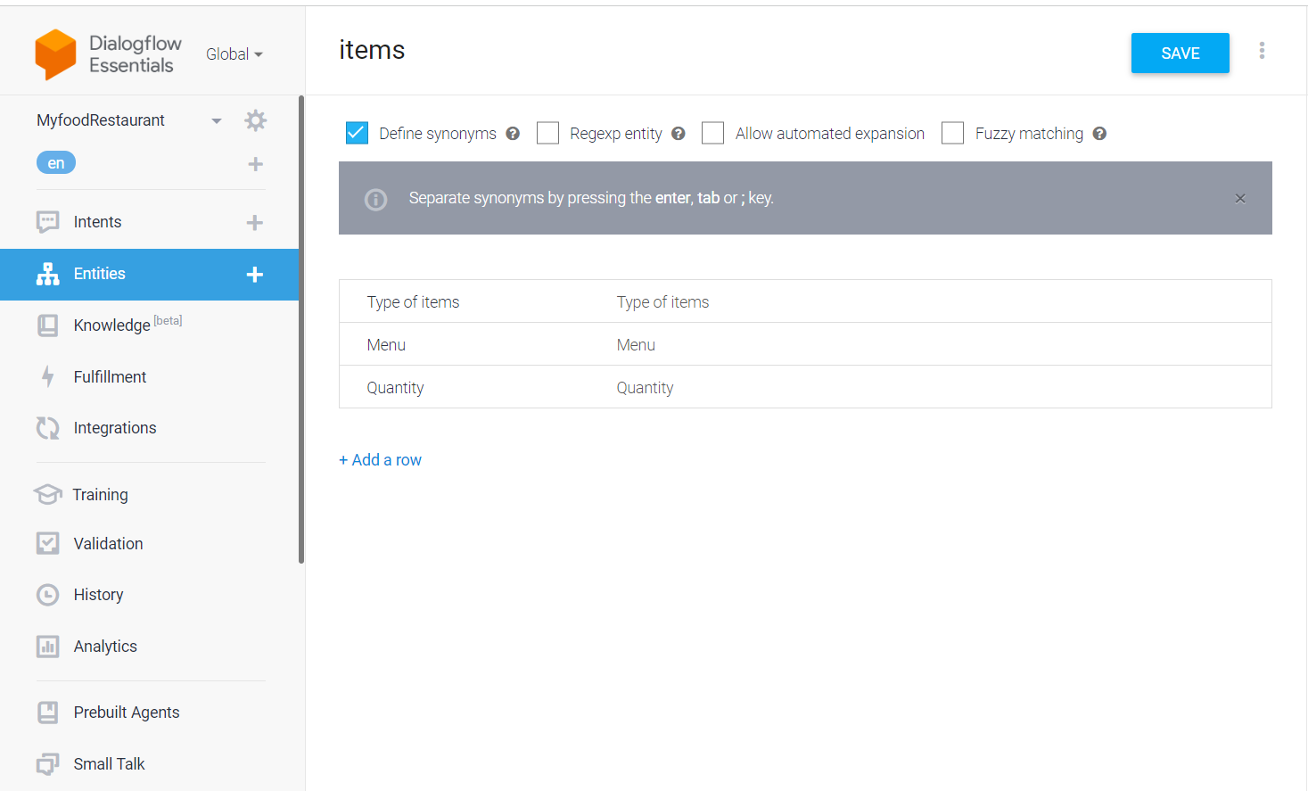

Step 4: **Intents**

Intent refers to the goal that customer has in mind when typing in a question or comment. While entity refers to the modifier the customer uses to describe their issue, intent is what they really mean. Here, I created several intents that are included in the below screen shots taken from the google dialogflow-chatbot.

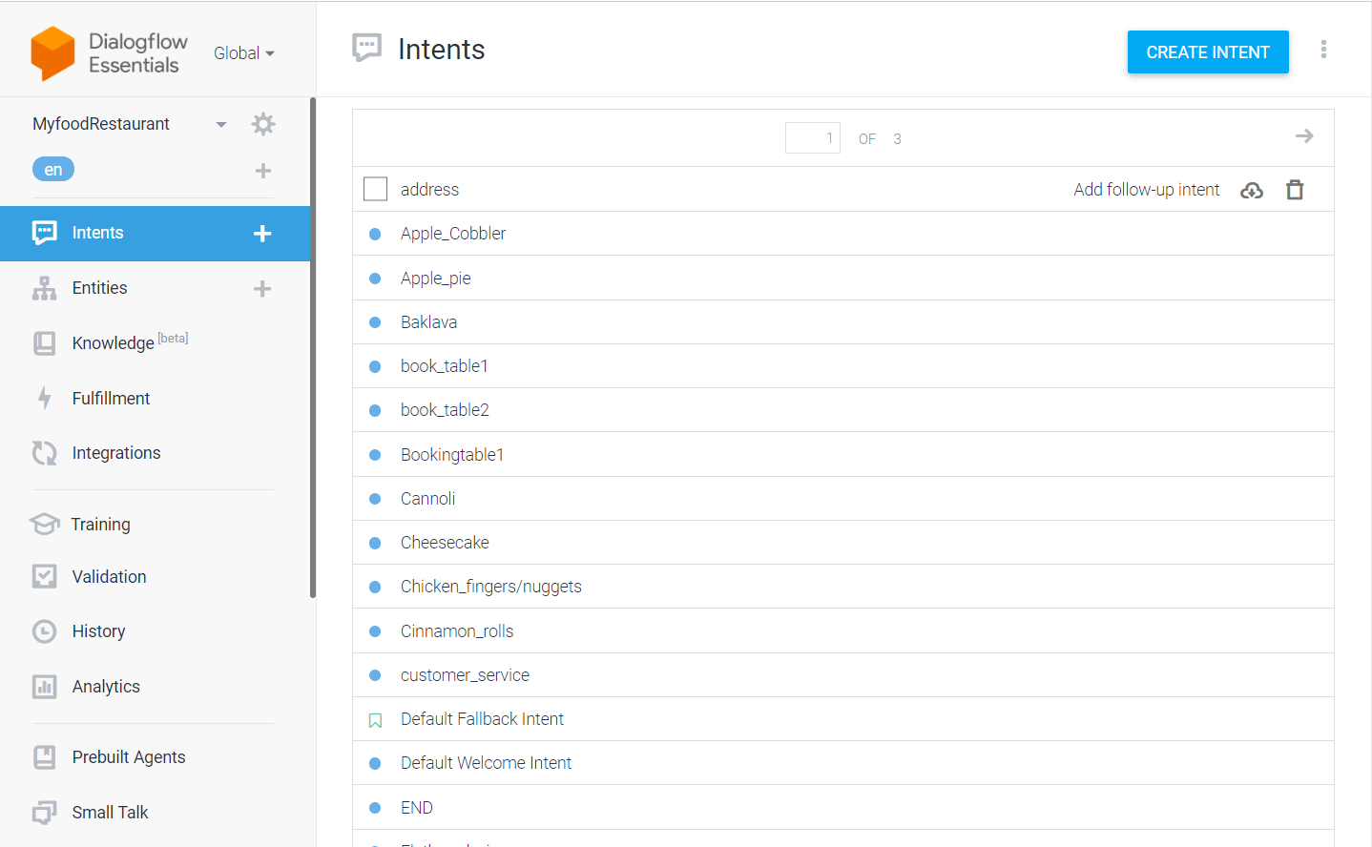

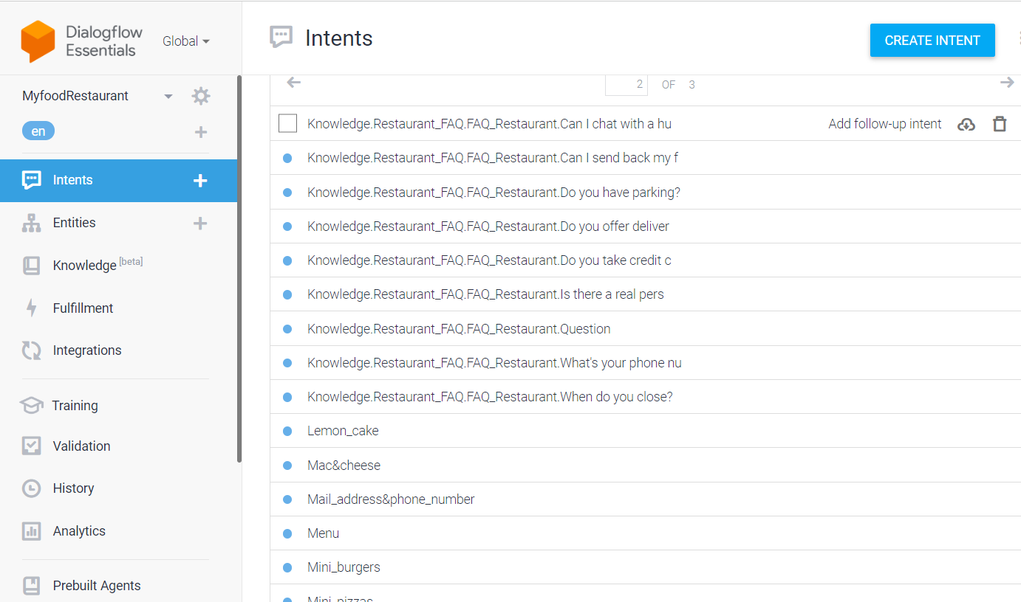

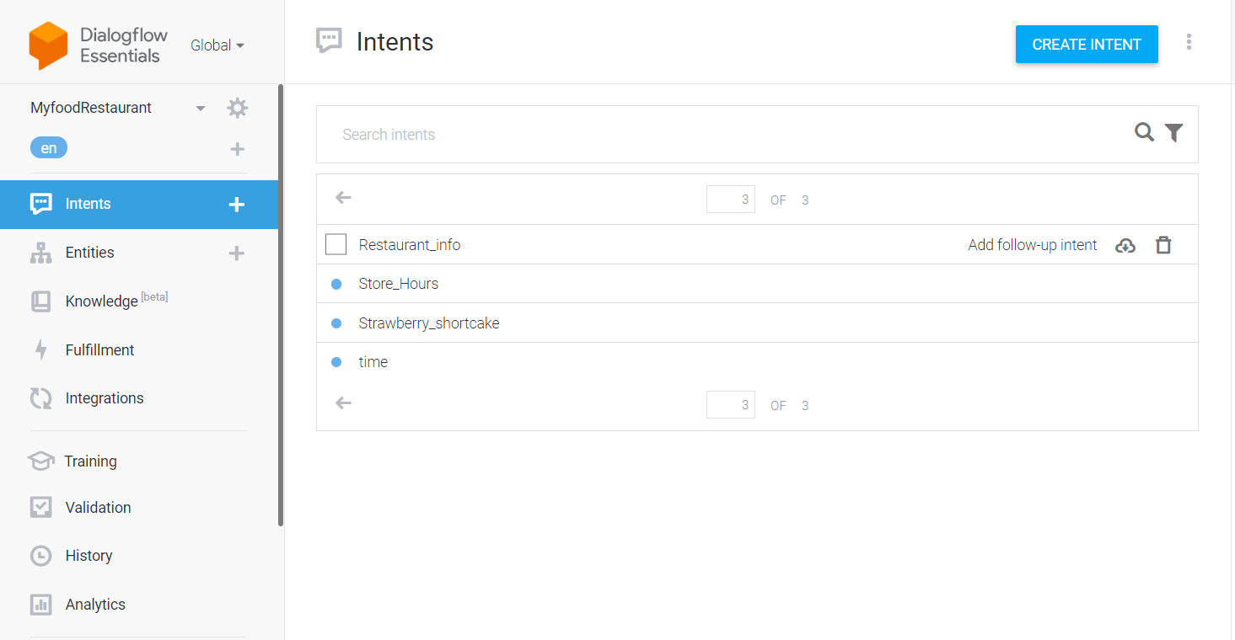

Step 5: **Creating the Knowledge Base**

I also started noting down some the possible Questions that the user can have, the possible ways of asking the Questions.

I arranged the Questions and answers in a excel file. Below is the sample snap of that file.

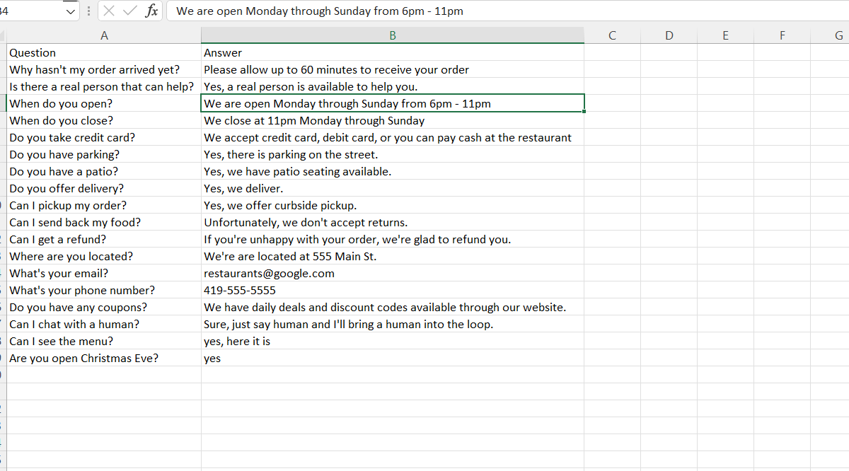

I integrated this excel sheet with Google Dialogflow by using Knowledge (beta) feature. This Feature allows to connect with the CSV files, URLS etc…… To enable this feature, one has to turn on “Enable beta features and APIs” in the Dialogflow.

Click on the ⚙️ (Gear icon) on the left side panel near the Agent name.

Under the “BETA FEATURES” section, enable the “Enable beta features and APIs” option

On the left-hand side panel, click on the “Knowledge” option and select the “CREATE KNOWLEDGE BASE “

You can give your knowledge base a suitable name and save it. I have saved it as FQA.

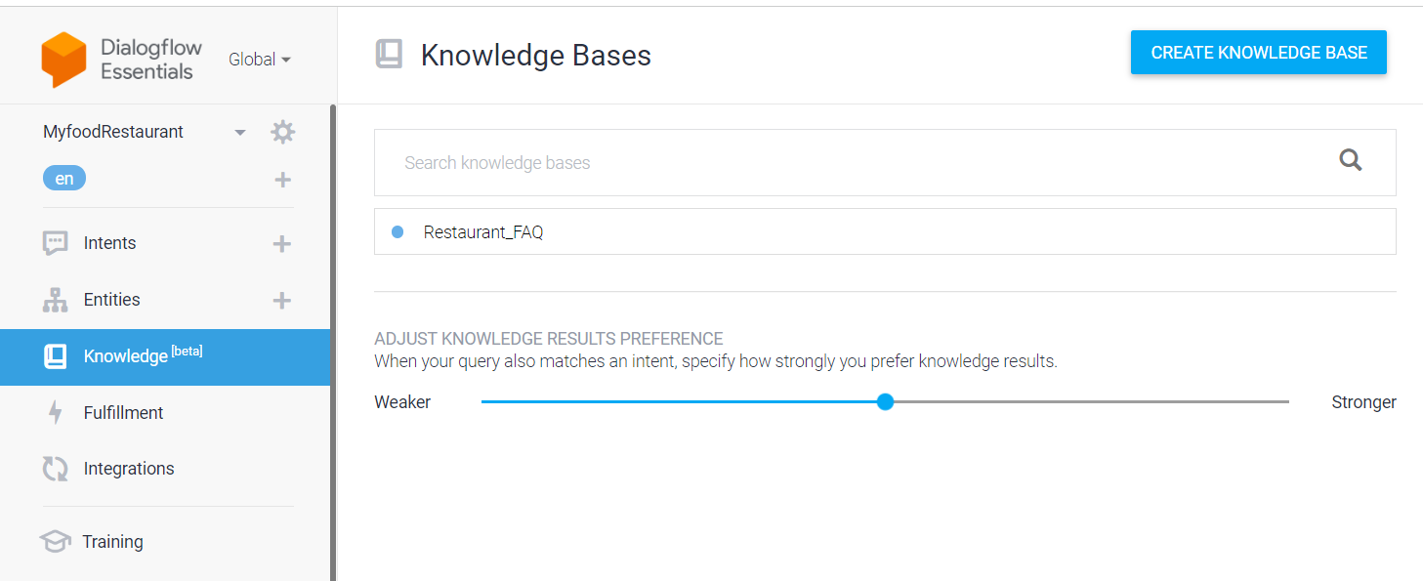

**Create a knowledge document and auto-generate a bot:**

Now, click on “Create the first one” option to create a knowledge document.

Customize the knowledge document fields

Customize the Document fields according to your requirements.

Enter a ‘Document Name’, which can be any name

Select the ‘Knowledge Type’

For the knowledge type ‘FAQ’, 2 mime types (the type of data you are going to feed to the bot) are supported

Give a ‘Data Source’ to the document: Data source is the file from where all the data for your Knowledge Base will come. It can be provided as a file on cloud storage ☁️ or local 🖥️, you can also give this as a URL to a public page.

I have converted all the Questions from Google sheets in to Intends after that save it.

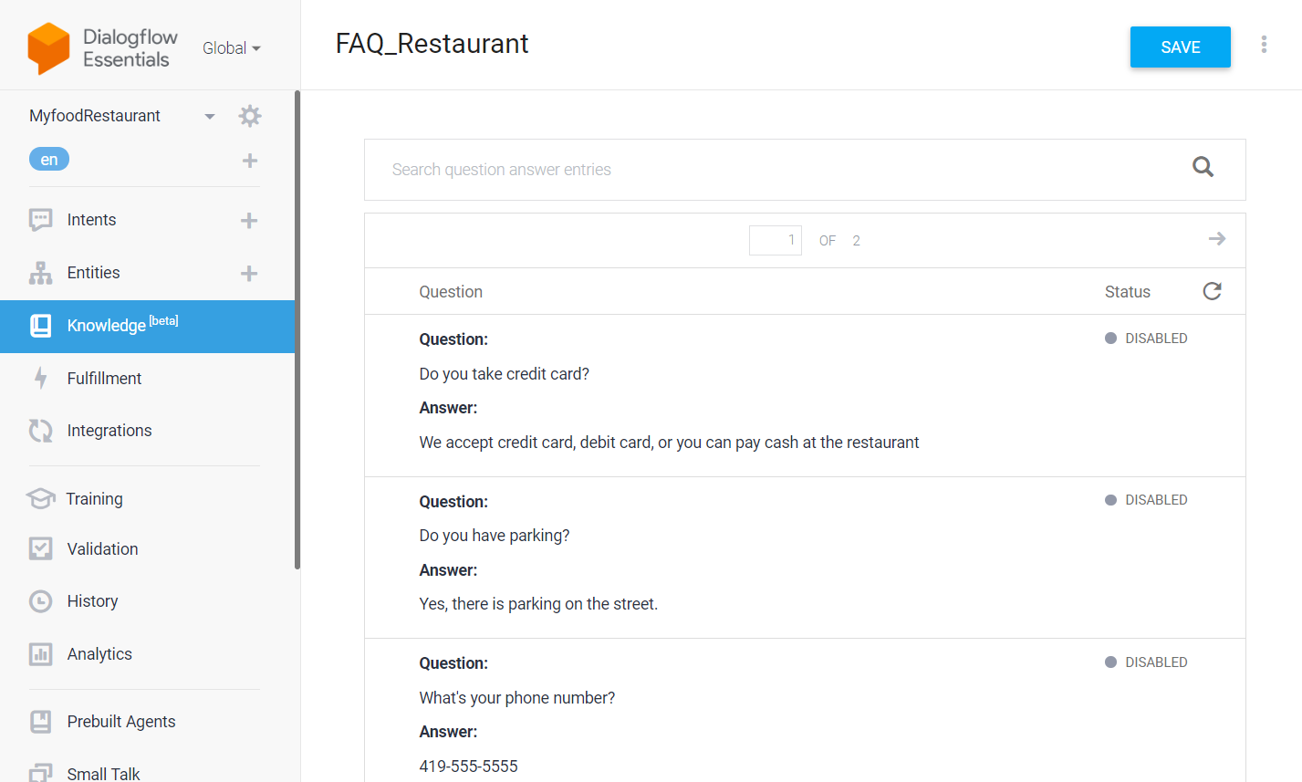

Step 6: **Training phrases**

Training phrases are example phrases for what end-users might type or say, referred to as end-user expressions. For each intent, you create many training phrases. When an end-user expression resembles one of these phrases, Dialogflow matches the intent.

I used the following phrases to train and match dialogflow it to the intent.

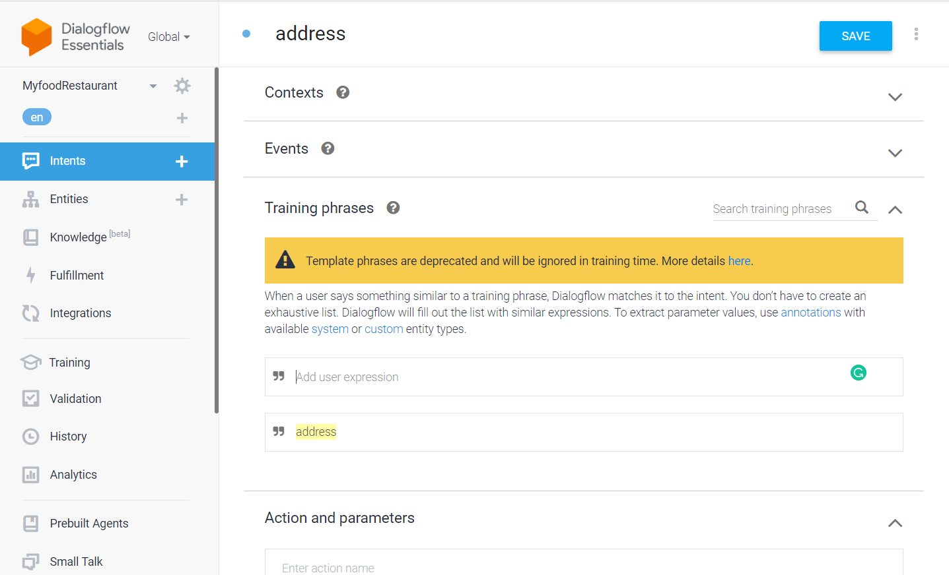

Step 7: **Actions and parameters**

Dialogflow sends an API interaction response for each step of slot filling. For each of these slot filling responses, the intent and action will be the same, and the parameters collected so far will be provided. When building an agent, we provide prompts that the agent will use to get parameter data from the end-user.

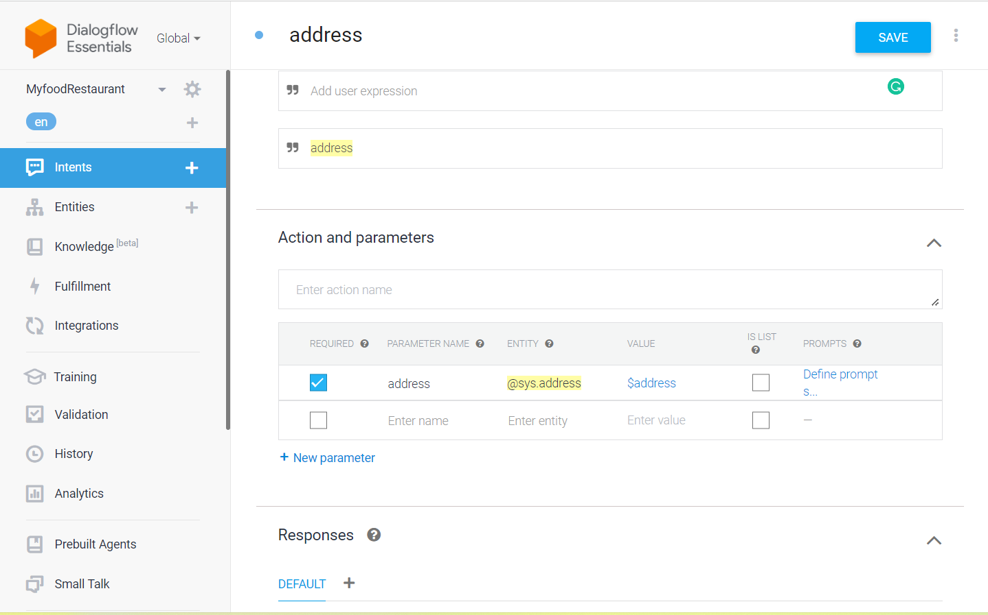

Step 8: **Responses**

The responses available are Text, Option, Pause and Image. I used only the text response type which is used for ordinary text responses.

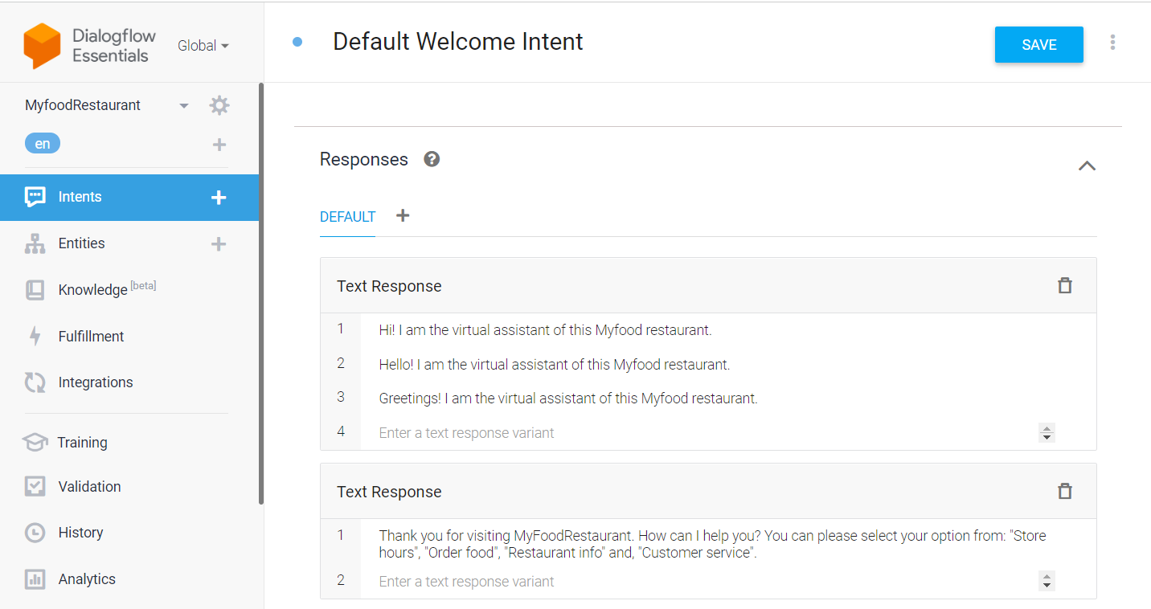

**CHAT RESPONSES**

The below are some of the chatbot responses pages.

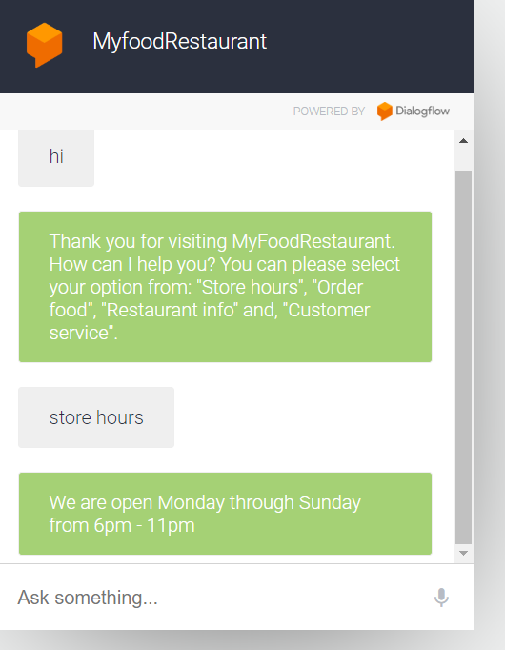 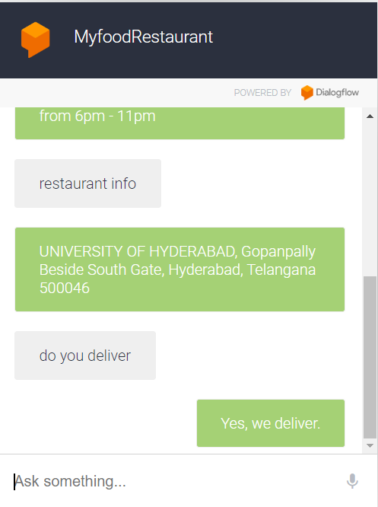

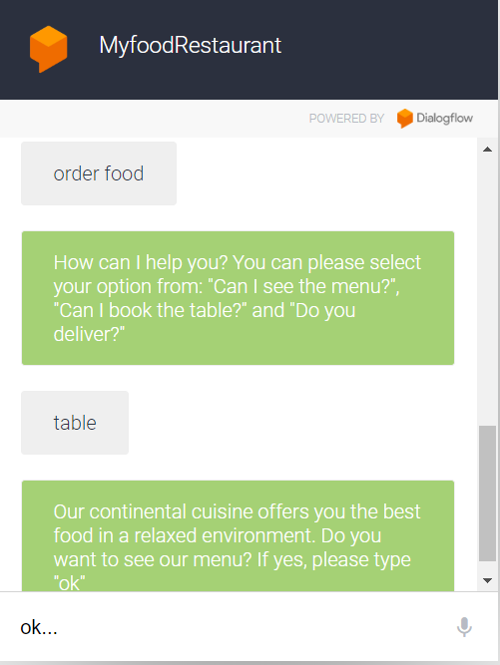 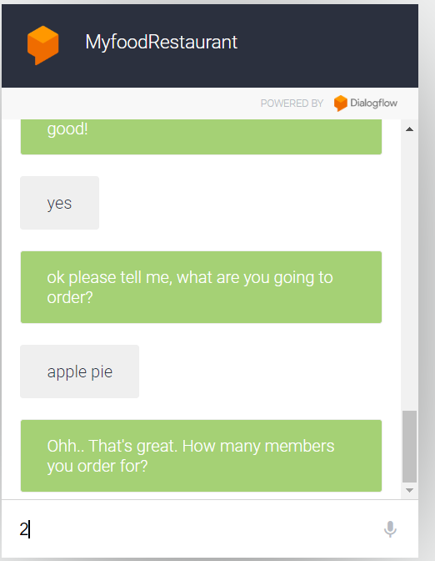

Chatbot link:

<https://bot.dialogflow.com/1e76f756-3789-419b-bfad-06276c2007f2>

Git hub link:

<https://github.com/SwargamNikhila>

<https://github.com/SwargamNikhila/MyFood-Restaurant-chatbot/upload/main>